TASK 1 BASIC NETWORK SNIFFER

First, to build a python program, I installed libraries necessary like scapy and pyshark.

Scapy simplifies the capturing analysis while pyshark is based on t shark which parses packet capturing.

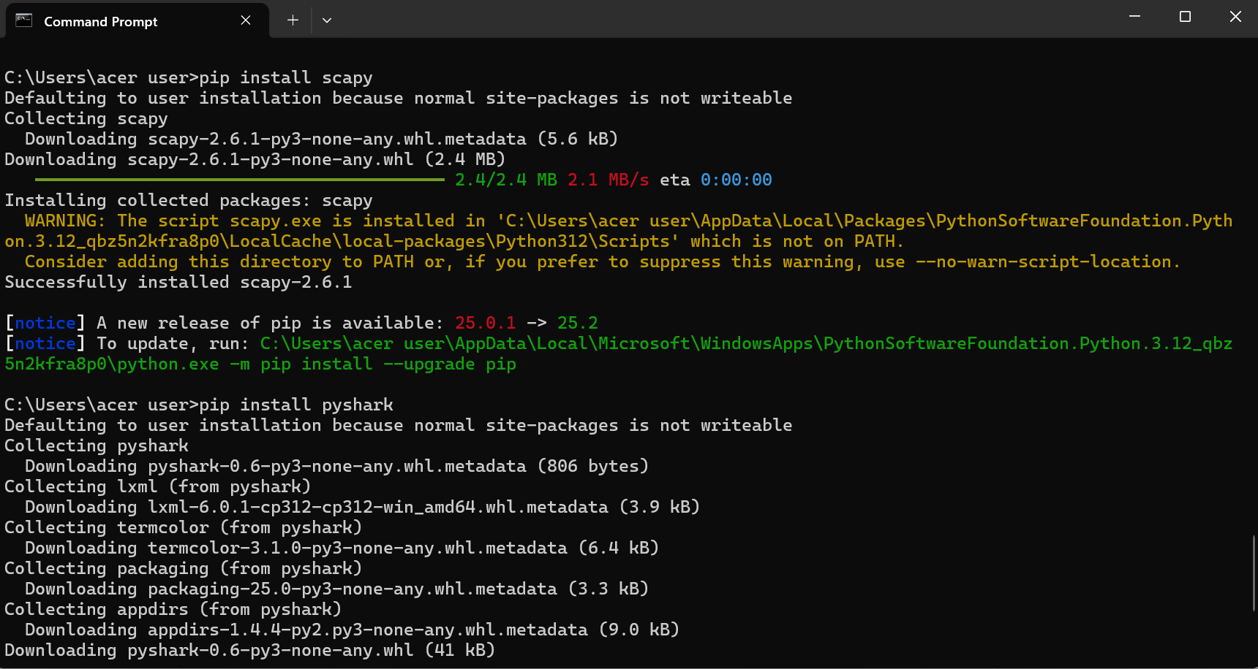

Next, to start capturing the packets, I imported the necessary modules from scapy:

Using python cmd this time:

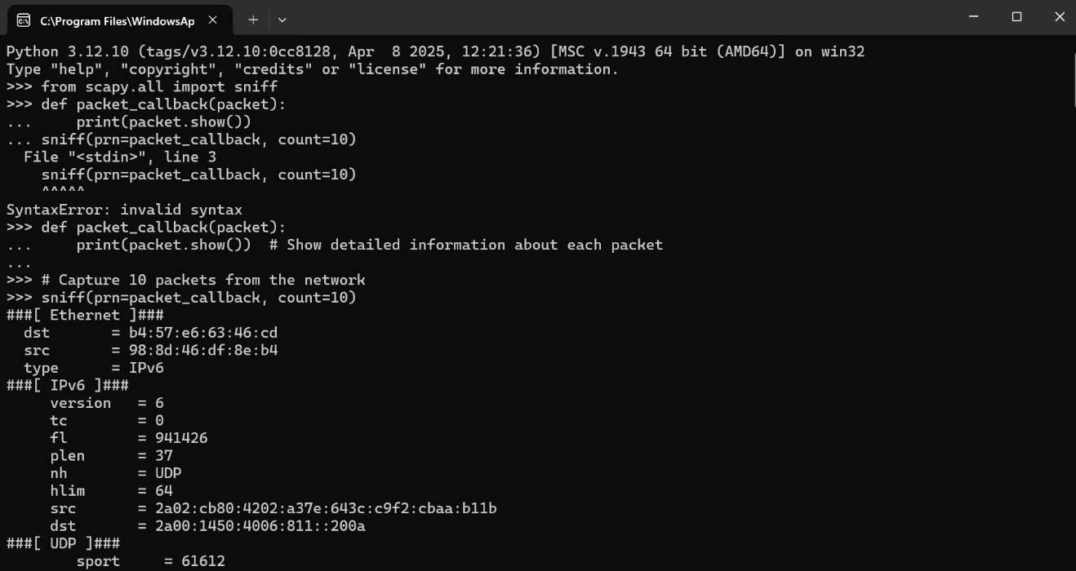

sniff() captures packets from the network. prn=packet_callback calls the function packet_callback() for each captured packet.

count=10 captures 10 packets

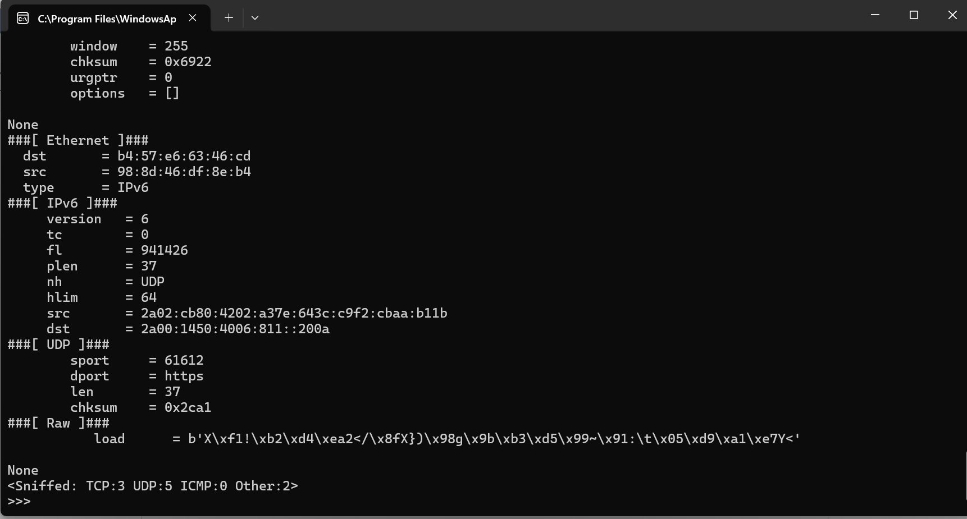

To further analyze the packets capturing I entered the following code :

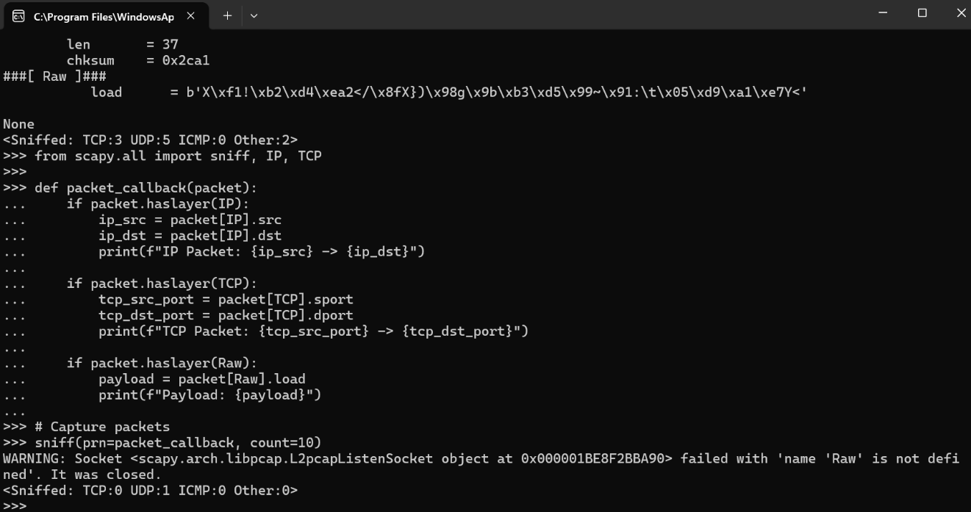

After that, I filtered by protocol :



Then by Port:

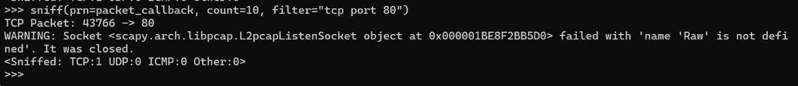

Next I analyzed the data flow through the network between two ips:

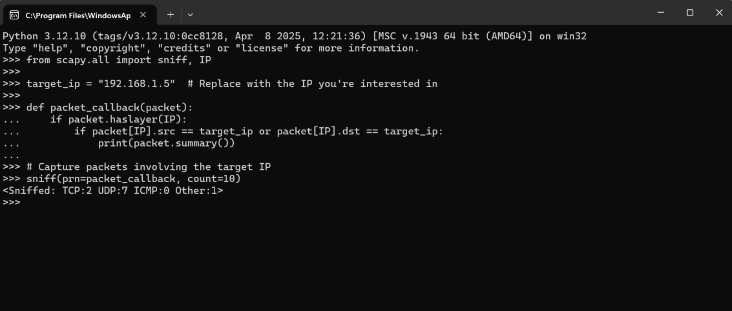

Then captured data for later analysis:

